QUESTION 2 – CPU SCHEDULING

1. Introduction
CPU scheduling is an important function of an operating system. It determines which process receives CPU time and in what order processes are executed.
In a cloud video-encoding service, different jobs may require different amounts of processing time. Short video jobs should receive quick responses, while longer encoding jobs should also receive sufficient CPU time.
The main objective is to compare CPU scheduling algorithms based on waiting time, turnaround time and context switches.

2. Problem Description
Consider a video-encoding service containing four jobs:
Process | Burst Time
P1 | 8
P2 | 4
P3 | 9
P4 | 5
All processes arrive at time 0.
The scheduling algorithms considered are:
- First Come First Serve (FCFS).
- Shortest Job First (SJF).
- Priority Scheduling.
- Round Robin Scheduling.

3. CPU Scheduling Metrics
Turnaround Time (TAT):
Turnaround time is the total time taken by a process from arrival to completion.
TAT = Completion Time − Arrival Time
Waiting Time (WT):
Waiting time is the total time a process spends waiting in the ready queue.
WT = Turnaround Time − Burst Time
Average Waiting Time:
Average WT = Total Waiting Time / Number of Processes
Average Turnaround Time:
Average TAT = Total Turnaround Time / Number of Processes

4. Round Robin Scheduling
Round Robin is a preemptive scheduling algorithm in which every process receives a fixed CPU time called a time quantum.
If a process does not complete within its allocated quantum, it is moved to the end of the ready queue.
The program was executed using three different time quantum values: 1, 3 and 20.

A. Round Robin – Quantum = 3
Gantt Chart:
P1(0-3) P2(3-6) P3(6-9) P4(9-12)
P1(12-15) P2(15-16) P3(16-19)
P4(19-21) P1(21-23) P3(23-26)

Process | TAT | WT
P1 | 23 | 15
P2 | 15 | 11
P3 | 24 | 15
P4 | 18 | 13
Average Turnaround Time = 20.00
Average Waiting Time = 13.50
Context Switches = 9

B. Round Robin – Quantum = 1
The CPU is allocated to each process for one time unit. This results in frequent switching between processes.

Observed Results:
Process | TAT | WT
P1 | 23 | 15
P2 | 12 | 8
P3 | 24 | 15
P4 | 17 | 12
Average Turnaround Time = 19.00
Average Waiting Time = 12.50
Context Switches = 25

C. Round Robin – Quantum = 20
Since the quantum is greater than the burst time of every process, each process completes in its first turn.
Gantt Chart:
P1(0-8) P2(8-12) P3(12-21) P4(21-26)

Process | TAT | WT
P1 | 8 | 0
P2 | 12 | 8
P3 | 21 | 12
P4 | 26 | 21
Average Turnaround Time = 16.75
Average Waiting Time = 10.25
Context Switches = 3

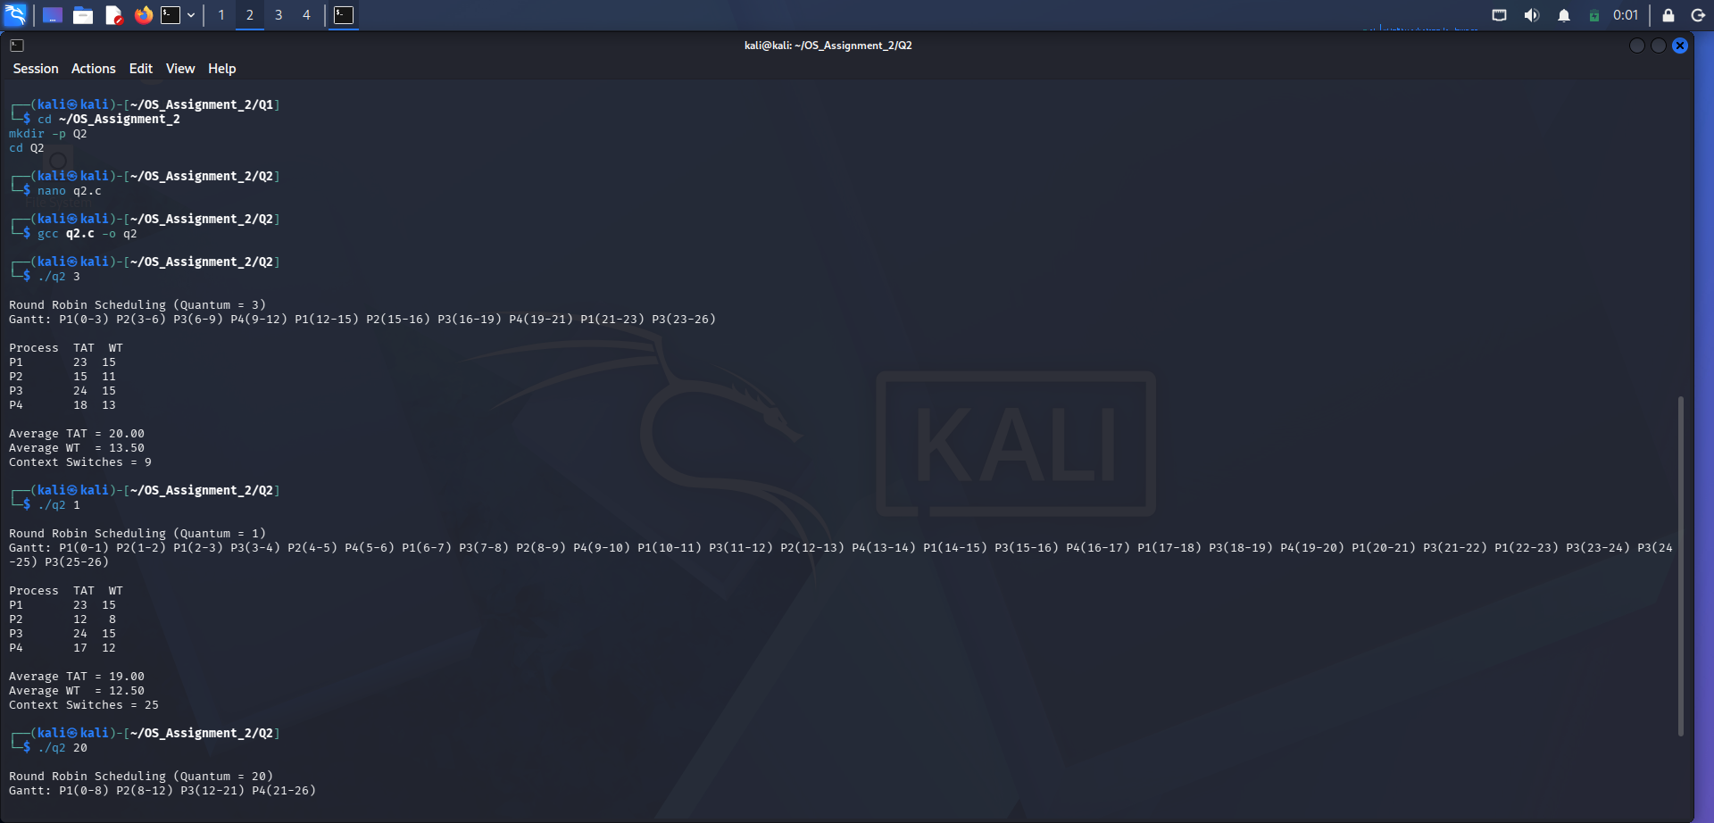

5. Evaluation of Time Quantum
The time quantum directly affects scheduling performance.
- A very small quantum increases context switching.
- A very large quantum reduces preemption and behaves similarly to FCFS.
- A medium quantum provides a balance between response time and context-switching overhead.
For the given workload, quantum 20 produces only three context switches, while quantum 1 produces 25 context switches.

6. FCFS, SJF and Priority Scheduling
FCFS: Processes are executed in their arrival order. Since all processes arrive at time 0, the execution order is P1, P2, P3 and P4.
SJF: The process with the shortest burst time is selected first. For the given workload, the execution order is P2, P4, P1 and P3.
Priority Scheduling: The process with the highest assigned priority is selected first. The priority values must be specified before calculating its Gantt chart and average waiting time.
For this workload, FCFS and non-preemptive SJF can be compared directly. Priority results depend on the priority values assigned to the four jobs.

7. Design Decision
For a cloud video-encoding service, Round Robin is useful when multiple users require fair CPU access. However, using a very small quantum creates unnecessary context switches.
A suitable medium quantum or a feedback-based scheduling approach can improve responsiveness while ensuring that long jobs receive CPU time.

8. Alternative Concept and Complexity Analysis
A Multilevel Feedback Queue can be used instead of a fixed Round Robin queue.
Short jobs can remain in higher-priority queues, while longer jobs can move to lower-priority queues.
This improves the response time of short jobs and reduces the risk of starvation when aging is applied.
The scheduling algorithms require different levels of overhead depending on queue management, process selection and context switching.

9. Conclusion
The experiment demonstrated Round Robin scheduling with quantum values 1, 3 and 20.
The results showed that a smaller quantum increases context switches, whereas a larger quantum reduces switching overhead. Therefore, scheduling parameters should be selected according to the workload and response-time requirements.

